Module 7: Assignment Using Server-Side Rendering with PUG Server

Spurthy Mutturaj

Instructor: Dinesh Sthapit

Oct 27,2022

GitHub:

<https://github.com/spurthym/Middleware-Programming/tree/main/Module7%20Assignment2%20PUG>

Successful Connection to the Database

App.js File, Including the pug and view engine on lines 12 and 13

Pug template to render on Browser:

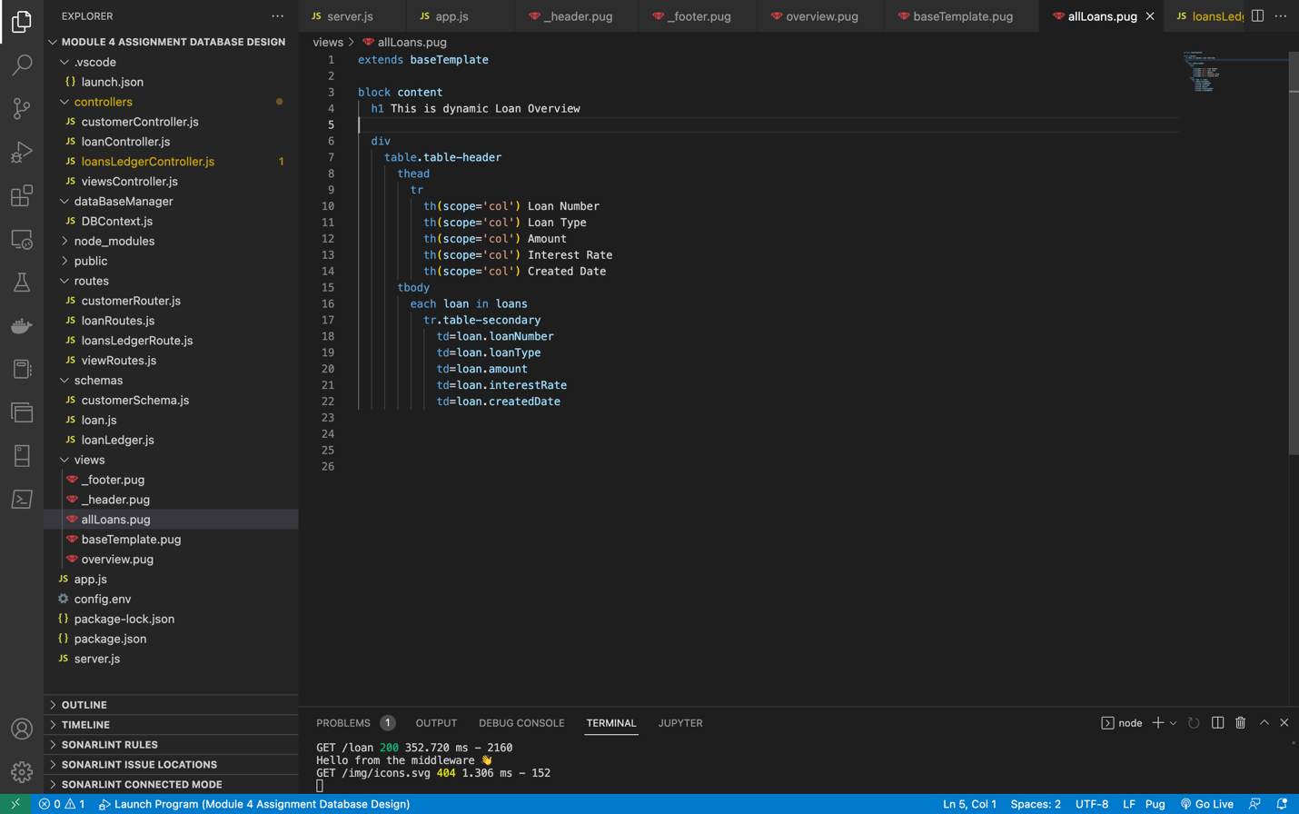

The loan is queried from MongoDB and rendered to the Pug Template on lines: 14 and 15

Browser Screenshots

Clicking on All Loan Lists Tab, the loan stored in DB is rendered.

Loan has only 3 entries which is rendered successfully.

Step 2:

The Pug templates have been reused by componentizing it as _header ,baseTemplate and _Footer:

Public folder containing all the HTML Files

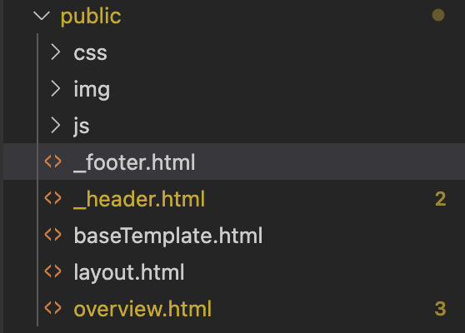

Views Folder containing all the pug UI elements

HTML Files:

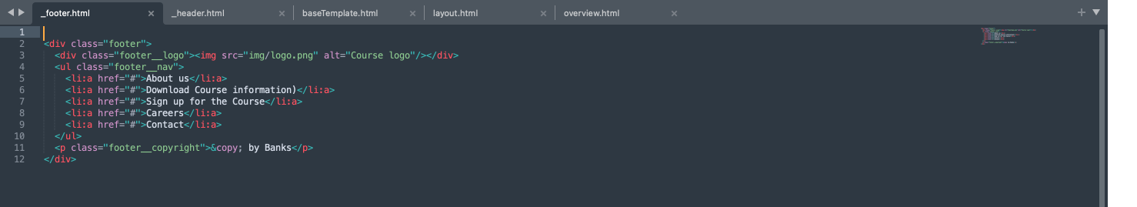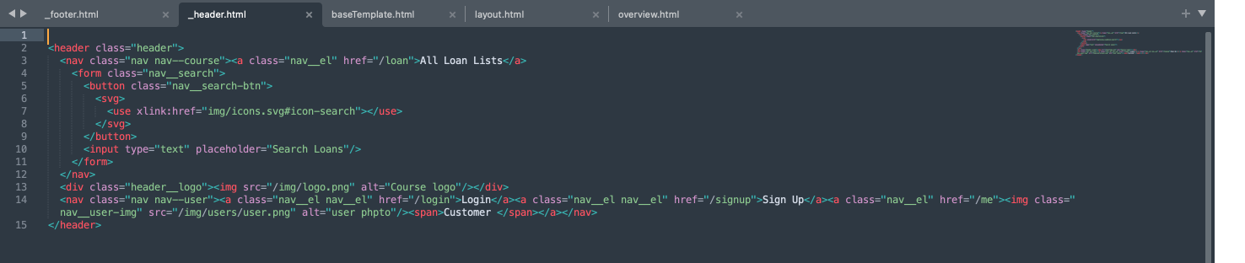

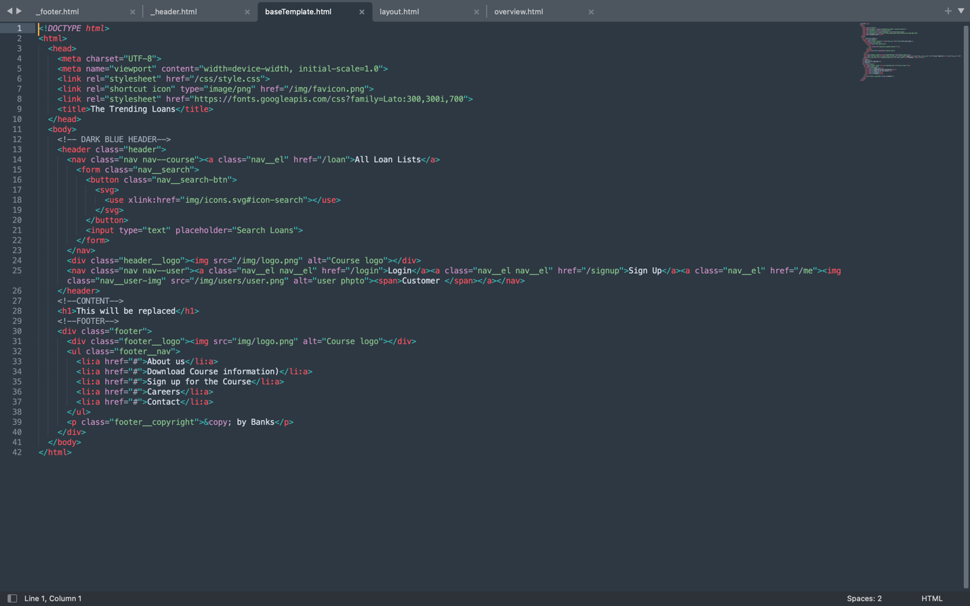

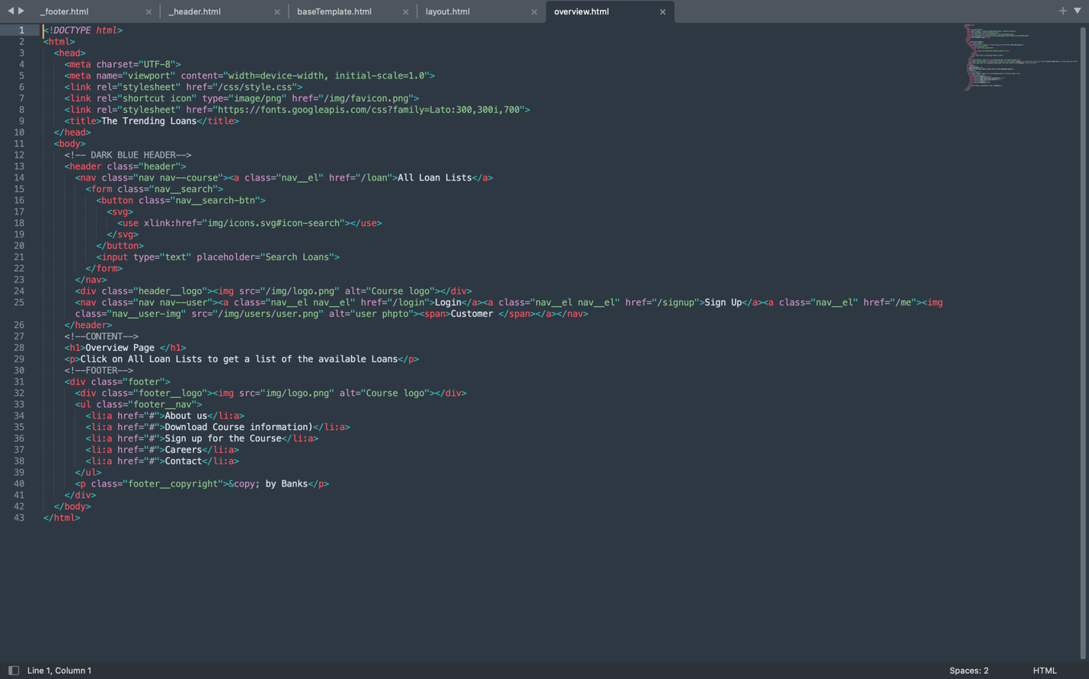

**PUG Files**

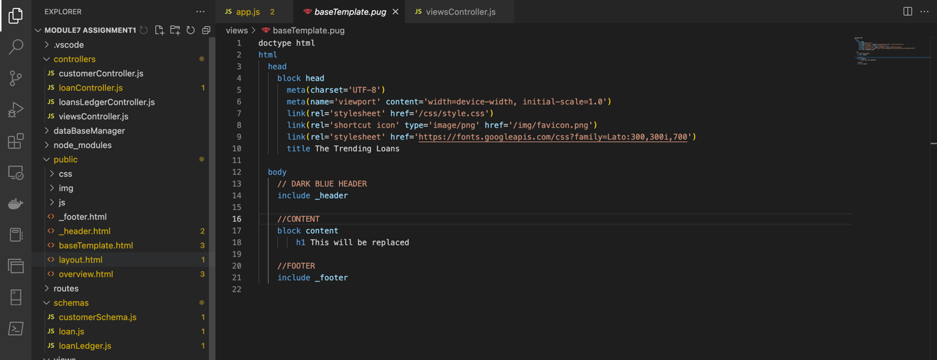

Using the Live Server

